**AAE6102 Assignment 1 Report**

### Task 1 – Acquisition

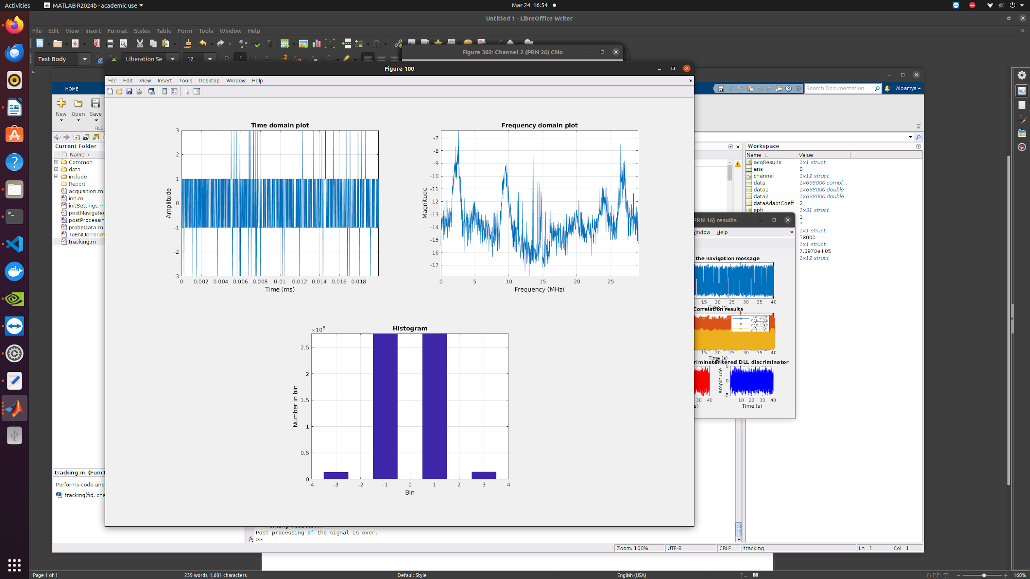First we perform acquisition of GPS signals from raw front-end data. Our code searches for signals from satellites specified in the settings structure by correlating the incoming signal with locally generated C/A codes. The function first processes the input signal (potentially resampling it to speed up acquisition), then performs a two-step acquisition process: a coarse search across frequency bins and code phases, followed by a fine resolution frequency search for detected signals. For each satellite, it calculates the correlation peak ratio to determine if a signal is present, and if found, it stores the code phase and carrier frequency in the output structure.

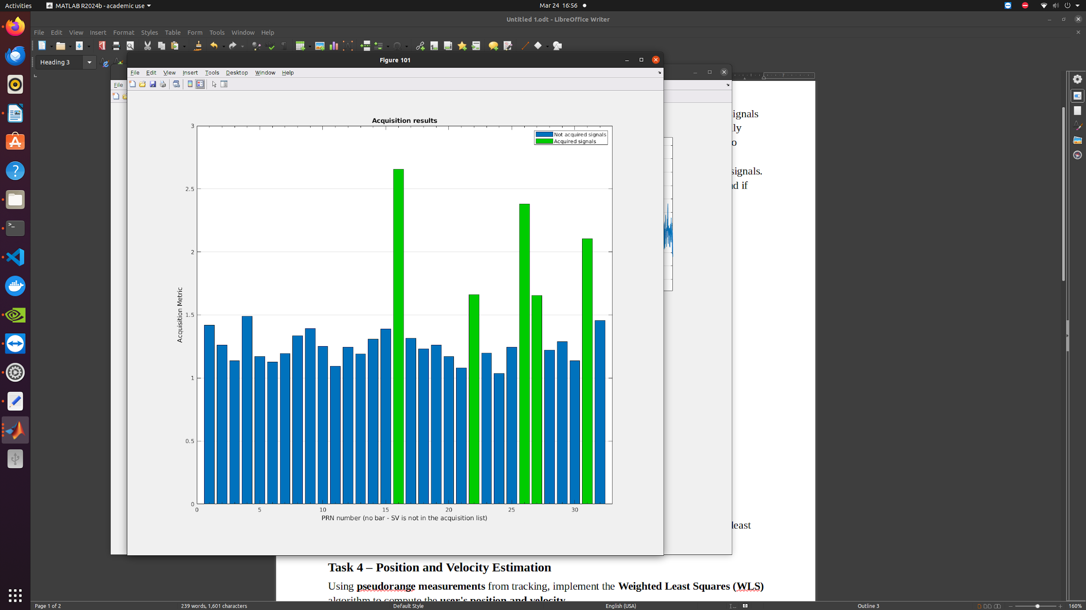

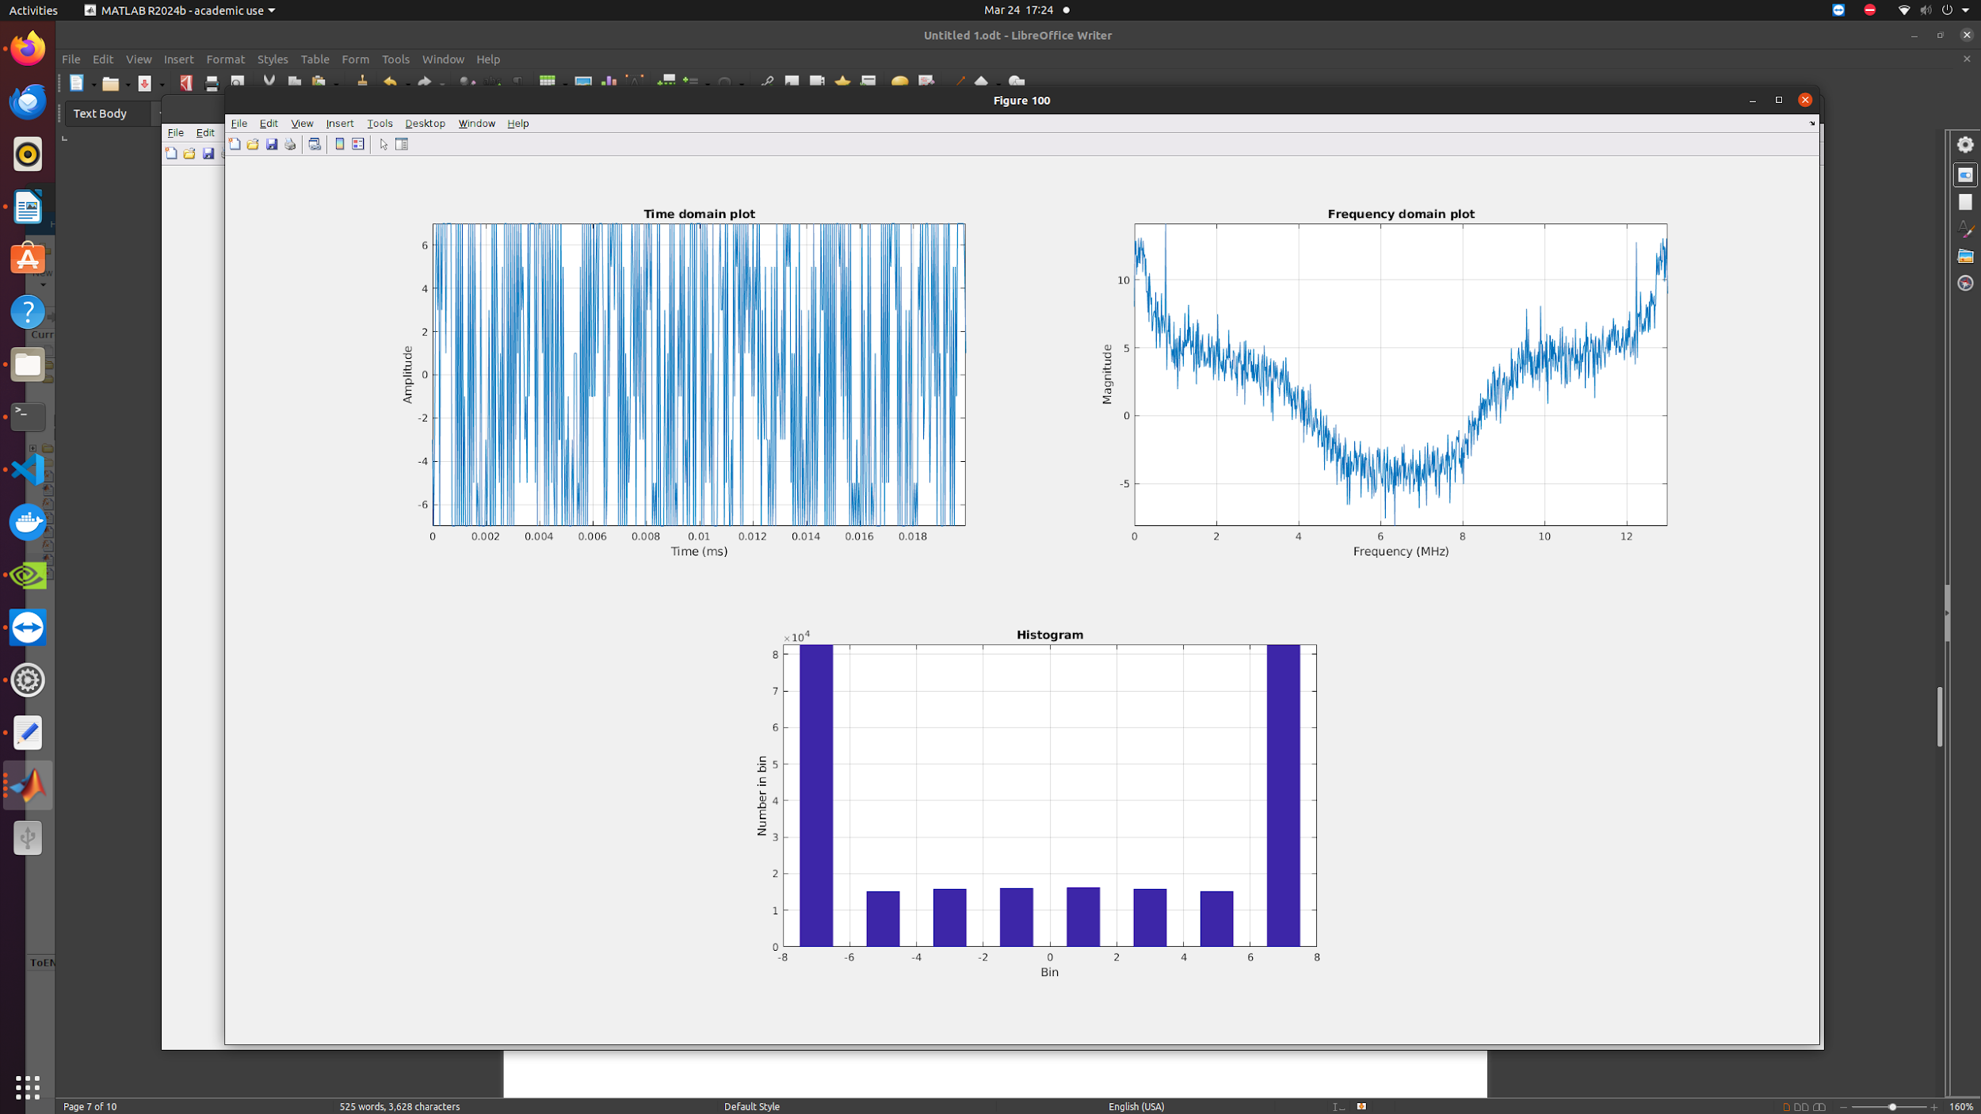Fig.1 Acquisition results (Opensky)

### 

Fig.2 Acquisition results (Urban)

### Task 2 – Tracking

Adapt the **tracking loop (DLL)** to generate **correlation plots** and analyze the tracking performance. Discuss the impact of urban interference on the correlation peaks. *(Multiple correlators must be implemented for plotting the correlation function.)*

Then we perform tracking of GPS signals for channels identified by the acquisition process. We implement both code tracking (DLL - Delay Lock Loop) and carrier tracking (PLL - Phase Lock Loop) to follow the signal as it changes over time. For each channel with an assigned PRN, the function generates local replicas of early, prompt, and late versions of the C/A code, mixes the incoming signal to baseband using carrier wave estimates, and calculates correlation values. These correlation values feed into discriminators that determine tracking errors, which are then filtered and used to adjust the code and carrier frequency estimates in a feedback loop. The function collects tracking metrics throughout processing, including signal strength (C/No), correlator outputs, and loop discriminator values, updating a progress bar every 50ms. The output structure contains detailed tracking results for each millisecond of processing across all active channels.

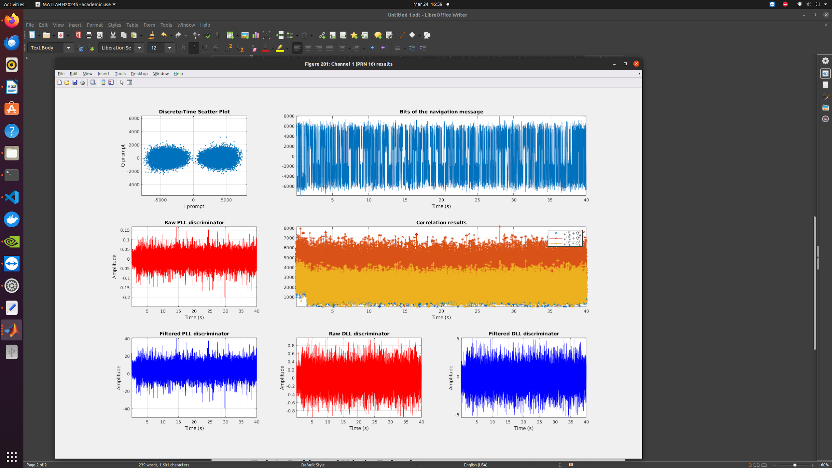

Fig.3 Channel 1 (RPN 16) results (Opeksky)

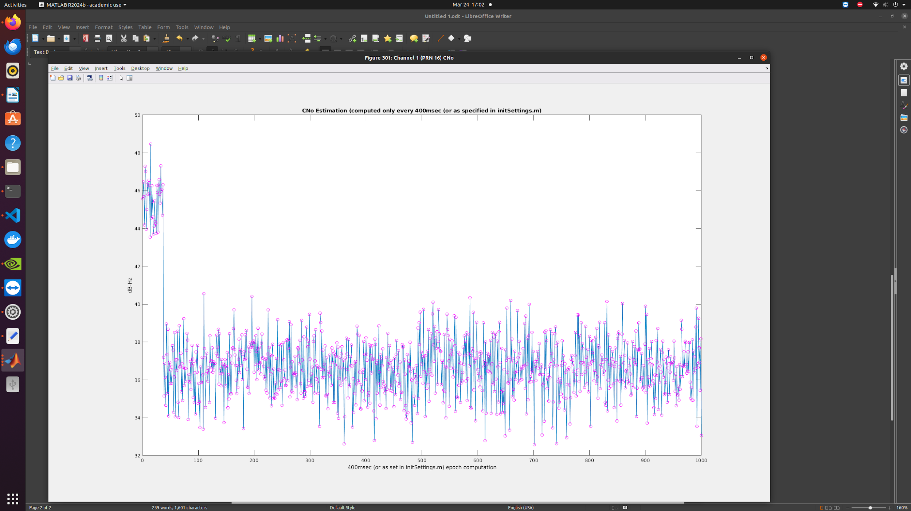

Fig.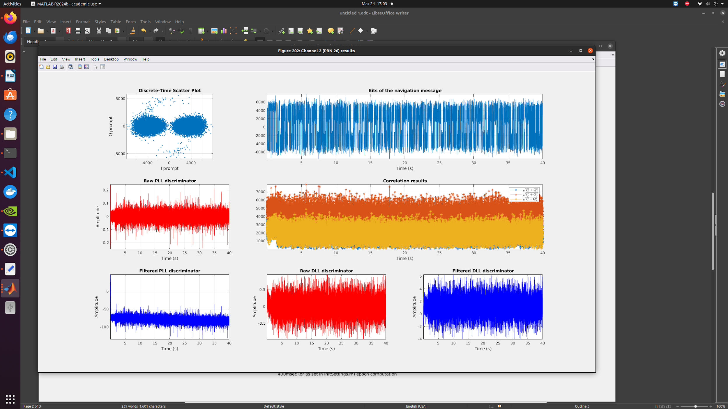4 Channel 1 (RPN 16) CNo (Opensky)

Fig.5 Channel 2 (RPN 26) result (Opensky)

### 

Fig.6 Channel 2 (RPN 26) CNo (Opensky)

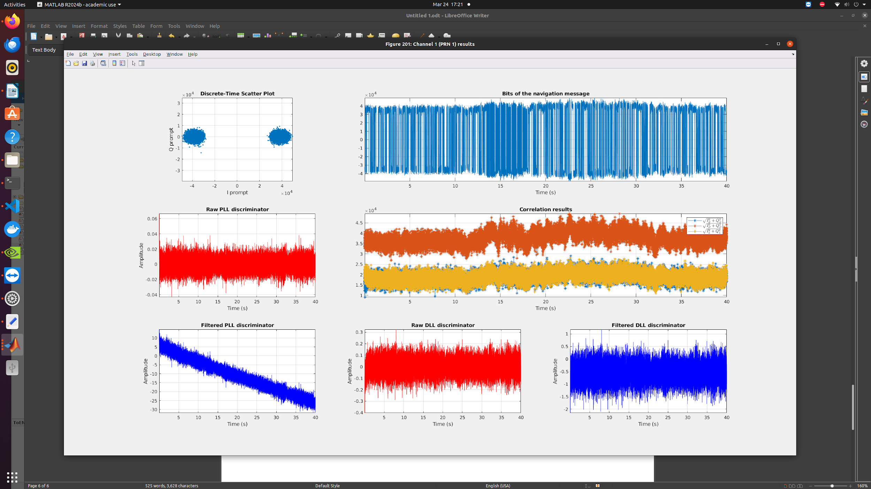

Fig.7 Channel 1 (RPN 1) results (Urban)

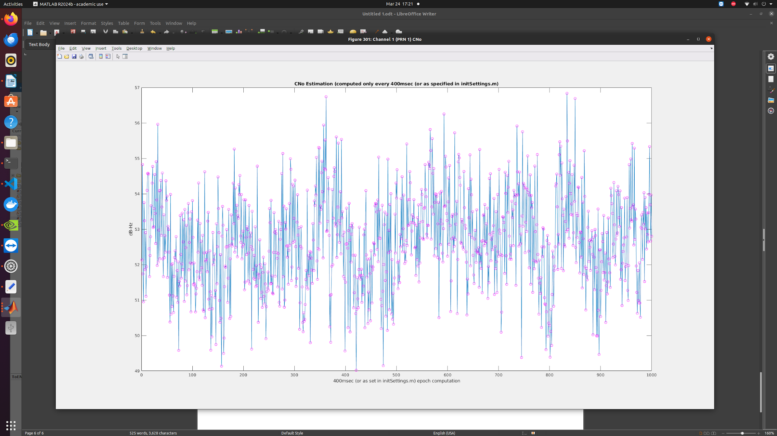

Fig.8 Channel 1 (RPN 1) CNo (Urban)

Urban multipath distorts these correlation functions:

Peak Asymmetry: The correlation triangle becomes asymmetric due to reflected signals, creating a bias in the detected peak position.

Peak Widening: The correlation function widens, reducing the sharpness of the peak and degrading range measurement precision.

Multiple Peaks: In severe multipath conditions, secondary peaks can appear, potentially causing the DLL to track an incorrect peak.

### Task 3 – Navigation Data Decoding

Decode the **navigation message** and extract key parameters, such as **ephemeris data**, for at least one satellite.

Decoding NAV for Urban dataset’s RPN 01:

TOW of first sub-frame: 449352 seconds  
    Ephemeris parameters for PRN 01:  
          C_ic: -7.4506e-08  
       omega_0: -3.1060  
          C_is: 1.6019e-07  
           i_0: 0.9761  
          C_rc: 287.4688  
         omega: 0.7115  
      omegaDot: -8.1696e-09  
      IODE_sf3: 72  
          iDot: -1.8108e-10  
       idValid: [2 0 3]  
    weekNumber: 1032  
      accuracy: 0  
        health: 0  
          T_GD: 5.5879e-09  
          IODC: 12  
          t_oc: 453600  
          a_f2: 0  
          a_f1: -9.4360e-12  
          a_f0: -3.4898e-05  
      IODE_sf2: 72  
          C_rs: -120.7188  
        deltan: 4.1909e-09  
           M_0: 0.5179  
          C_uc: -6.3349e-06  
             e: 0.0089  
          C_us: 5.3011e-06  
         sqrtA: 5.1537e+03  
          t_oe: 453600  
           TOW: 449352

The navigation part of our code takes tracking results for GPS satellites and calculates navigation solutions for the receiver. It first decodes ephemeris data from navigation messages in the tracking results, keeping only channels with complete ephemeris information. The function then processes measurement points sequentially, calculating pseudoranges between satellites and receiver at each point by comparing transmit and receive times. It determines satellite positions and clock corrections using the ephemeris data, then uses least squares estimation to solve for the receiver's position and clock error based on pseudorange measurements. For each valid position fix, the function converts the ECEF (Earth-Centered, Earth-Fixed) coordinates to geodetic (latitude, longitude, height) and UTM (Universal Transverse Mercator) coordinates, and calculates DOP (Dilution of Precision) values to indicate solution quality. The algorithm also applies satellite elevation masking, excluding satellites below a specified elevation angle from position calculations.

### Task 4 – Position and Velocity Estimation

Using **pseudorange measurements** from tracking, implement the **Weighted Least Squares (WLS)** algorithm to compute the **user's position and velocity**.

* 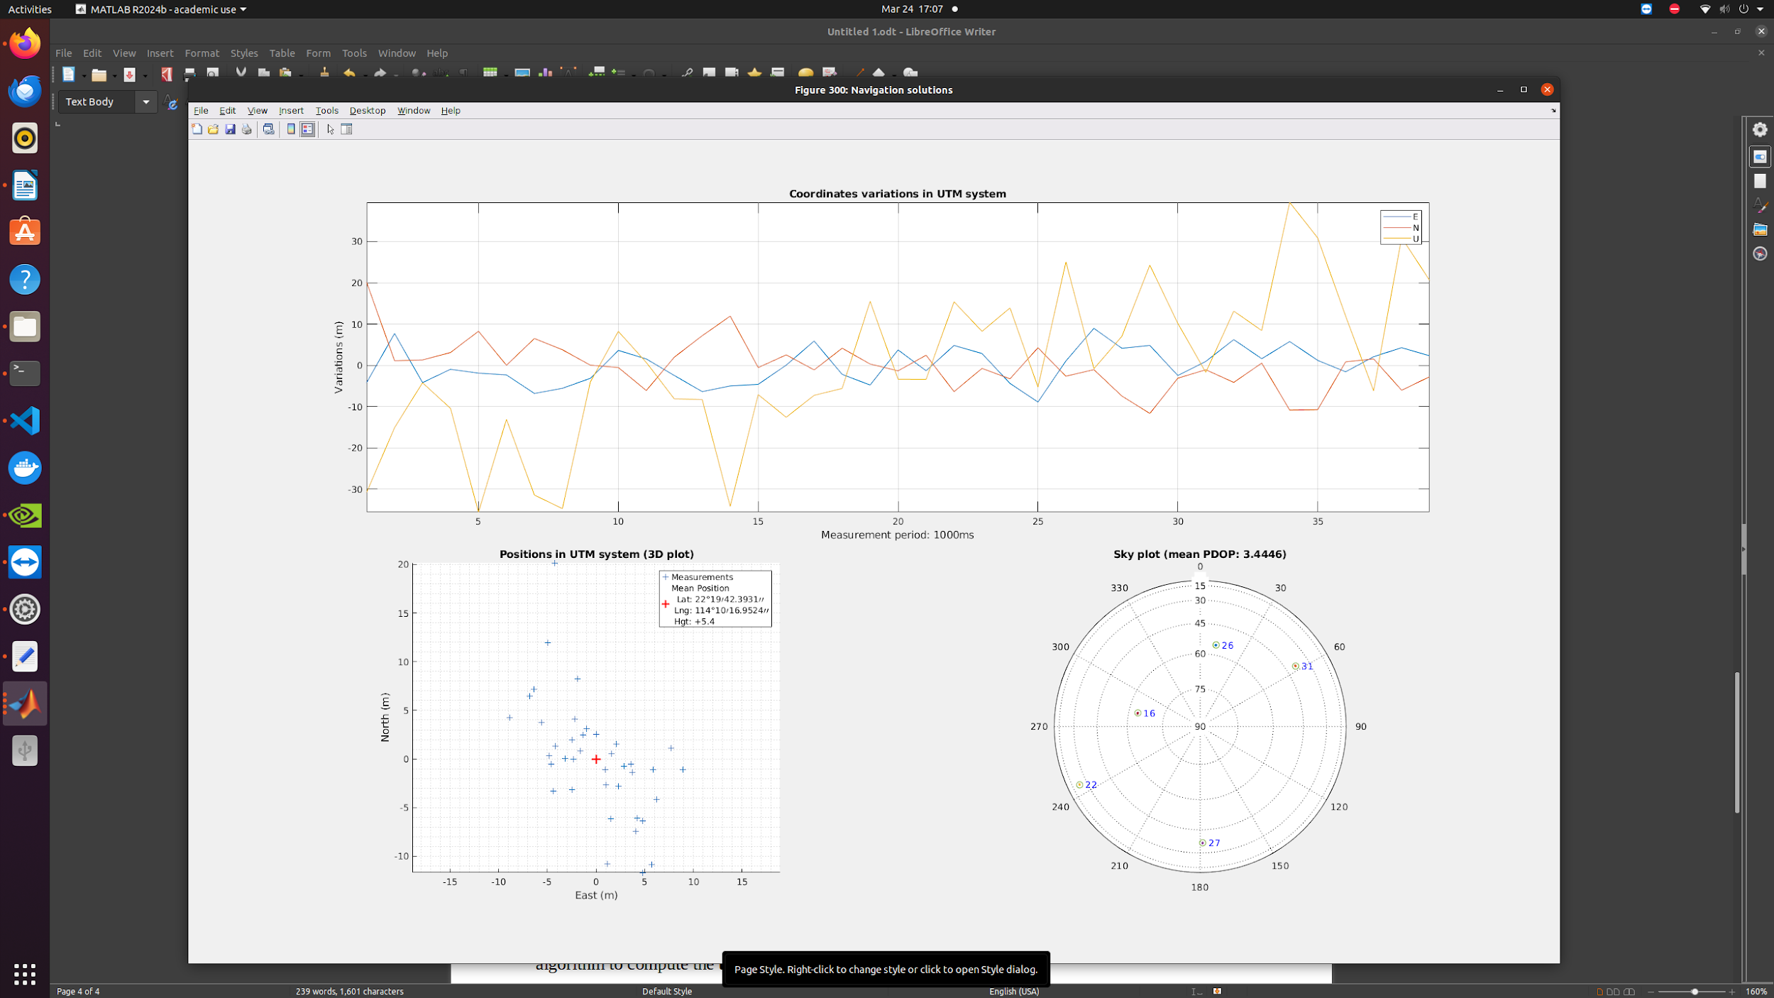Plot the user **position** and **velocity**.

Fig.9 Navigation results (Opensky)

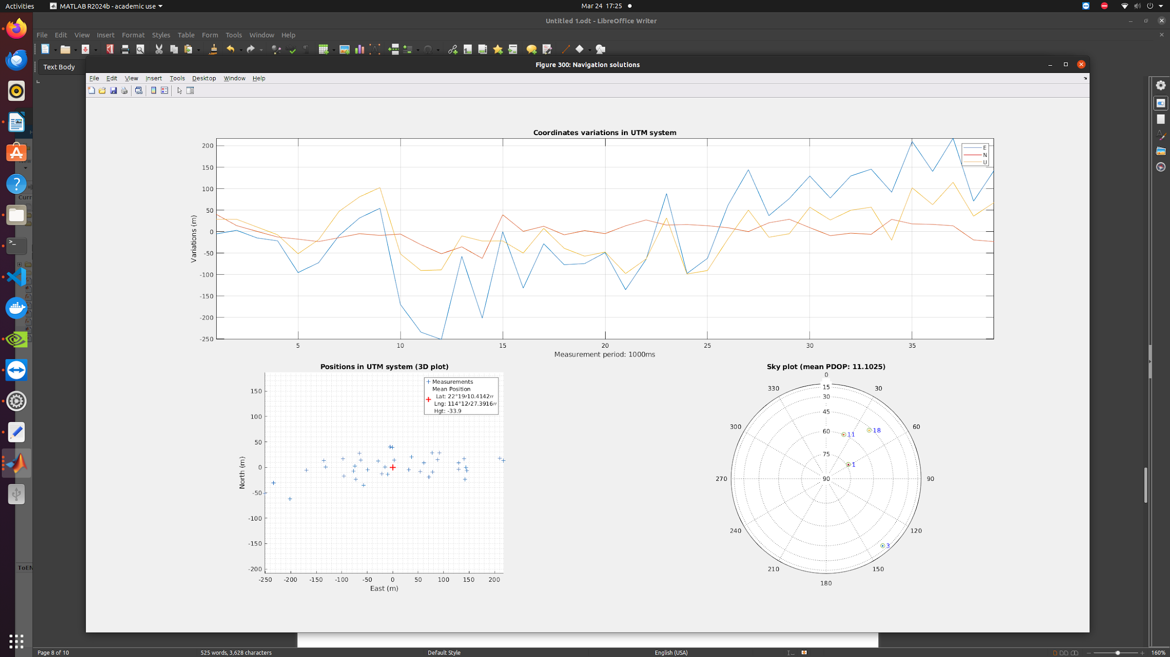

Fig.10 Navigation results (Urban)

* Compare the results with the **ground truth**.

Opensky:

|  |  |  |
| --- | --- | --- |
| Label | Latitude | Longitude |
| Ground Truth | 22.328444770087565 | 114.1713630049711 |
| Calculated (WLS) | 22.19423931 | 114.10169524 |

The difference is 16.556 km.

Urban:

|  |  |  |
| --- | --- | --- |
| Label | Latitude | Longitude |
| Ground Truth | 22.3198722 | 114.209101777778 |
| Calculated (WLS) | 22.19104142 | 114.12273916 |

The difference is 16.86 km.

* Discuss the impact of **multipath effects** on the WLS solution.

We can see that errors are quite large. Multipath occurs when satellite signals reach the receiver via multiple paths due to reflections from buildings, terrain, or other surfaces. These reflected signals cause errors in pseudorange measurements. Effects on the WLS Solution include: Position Accuracy Degradation, Weighting Issues, Correlated Errors and Solution Instability.

**Task 5 – Kalman Filter-Based Positioning**

Develop an **Extended Kalman Filter (EKF)** using **pseudorange and Doppler measurements** to estimate **user position and velocity**.

We have written the applyEKF function that implements an Extended Kalman Filter (EKF) for GPS navigation, providing improved position estimates compared to the standard Weighted Least Squares (WLS) approach.

**Key Components of the function:**

1. **State Vector**:
   * 4 states: X, Y, Z position coordinates in ECEF frame, and receiver clock bias (dt)
   * Uses a static position model with a random walk clock bias
2. **Initialization**:
   * Sets initial state from the first valid WLS solution
   * Initializes covariance matrices for state, process noise, and measurement noise
3. **Epoch Processing**:
   * Special handling for first 3 epochs during "initialization phase"
   * For each epoch, it processes visible satellites to calculate:
     + Predicted pseudoranges
     + Jacobian matrix of measurement model
     + Innovation vector (difference between measured and predicted pseudoranges)
4. **Robustness Features**:
   * Elevation-dependent measurement weighting
   * Innovation threshold check (1000m, increased to 5000m during initialization)
   * Limiting state corrections during initialization for stability
   * Higher process noise during initialization to allow faster convergence
   * Handling of singularities in matrix inversions
5. **Coordinate Conversions**:
   * ECEF to geodetic (latitude, longitude, height)
   * ECEF to UTM (E, N, U)
6. **DOP Calculation**:
   * Computes Dilution of Precision values (GDOP, PDOP, HDOP, VDOP, TDOP)

The function provides a more stable and accurate position solution than WLS by:

1. Filtering out measurement noise
2. Using the time history of measurements
3. Correctly modelling the system dynamics
4. Handling larger errors during initialization
5. Being more robust to outliers in the measurements

Opensky:

|  |  |  |
| --- | --- | --- |
| Label | Latitude | Longitude |
| Ground Truth | 22.328444770087565 | 114.1713630049711 |
| Calculated (EKF) | 22.3284 | 114.1717 |

The difference is 0.03502 km.

The position error was reduced by 99.79% by using the EKF approach.

Urban:

|  |  |  |
| --- | --- | --- |
| Label | Latitude | Longitude |
| Ground Truth | 22.3198722 | 114.209101777778 |
| Calculated (EKF) | 22.3196 | 114.208 |

The difference is 0.1173 km.

The position error was reduced by 99.30% by using the EKF approach

We can see that measurement error in the Opensky dataset is much smaller than Urban Dataset due to the absence of signal obstructions.

Output visualization for Urban dataset:

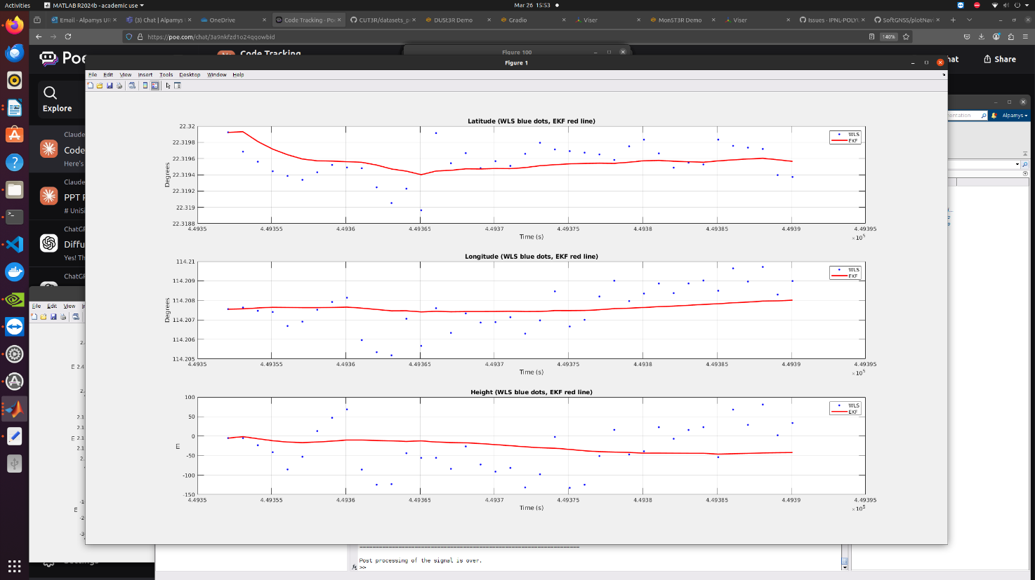

Fig. 11 Comparison of Latitude, Longitude and Height results derived by WLS (blue dots) method and EKF (red line) method (Urban)

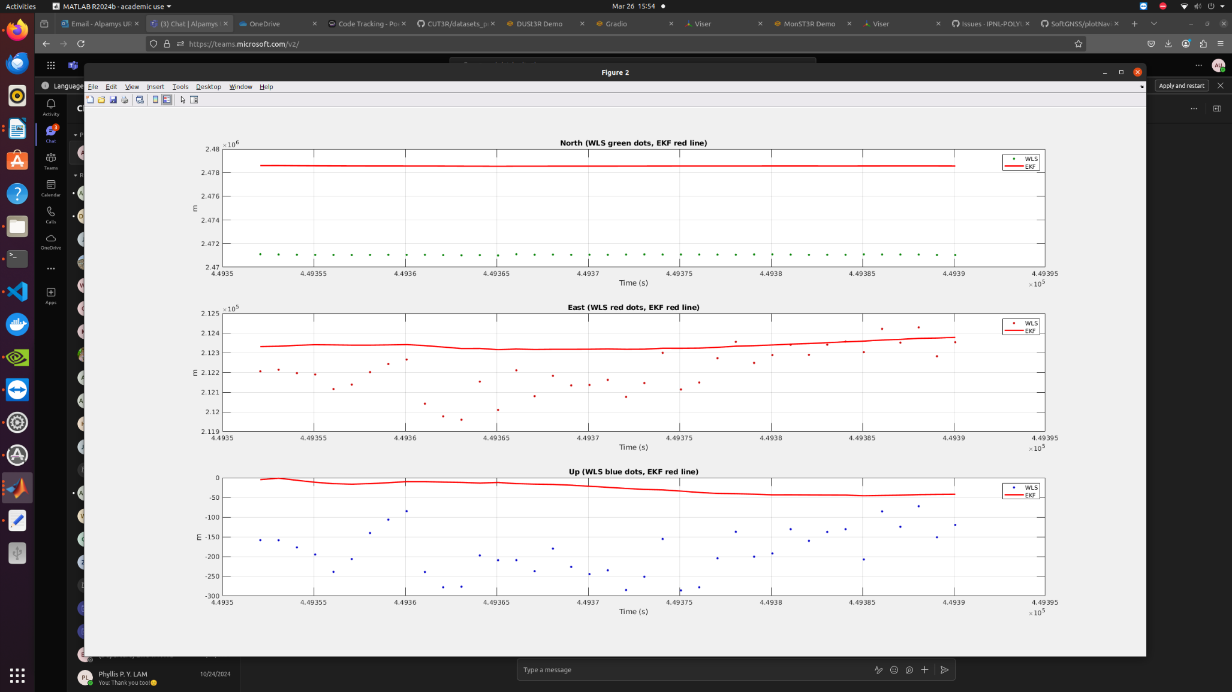

Fig. 12 Comparison of North, East, Up results derived by WLS (blue dots) method and EKF (red line) method (Urban)

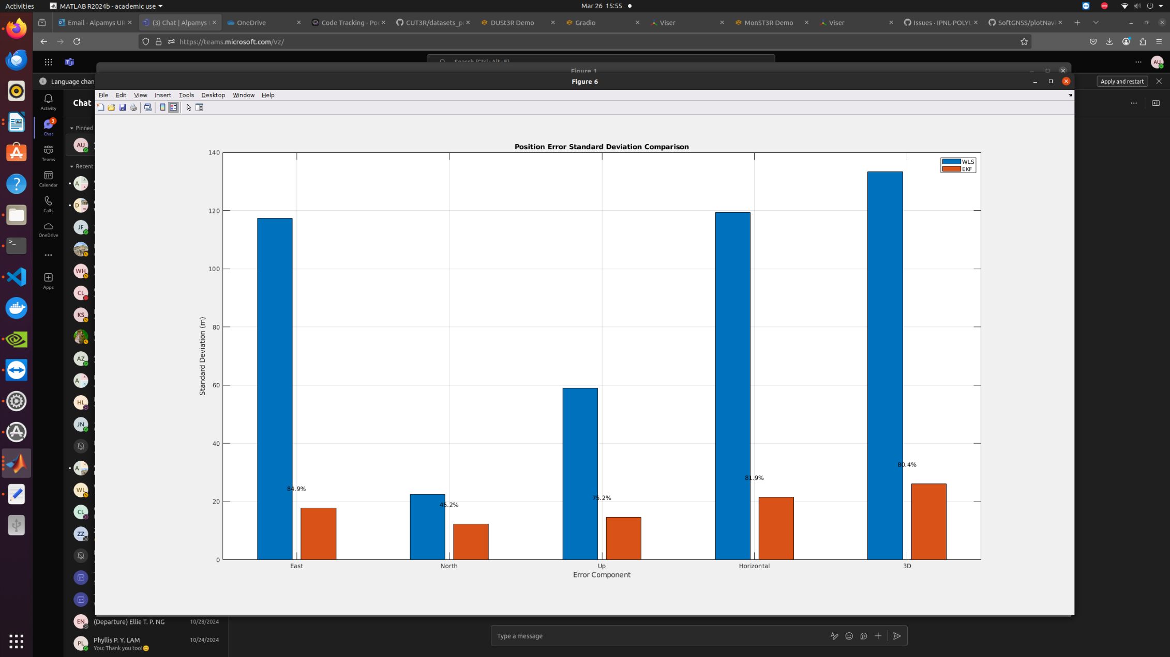

Fig. 13 Comparison of Position Error Standard Deviation from by WLS (blue dots) method and EKF (red line) method (Urban)

Output visualization for Opensky dataset:

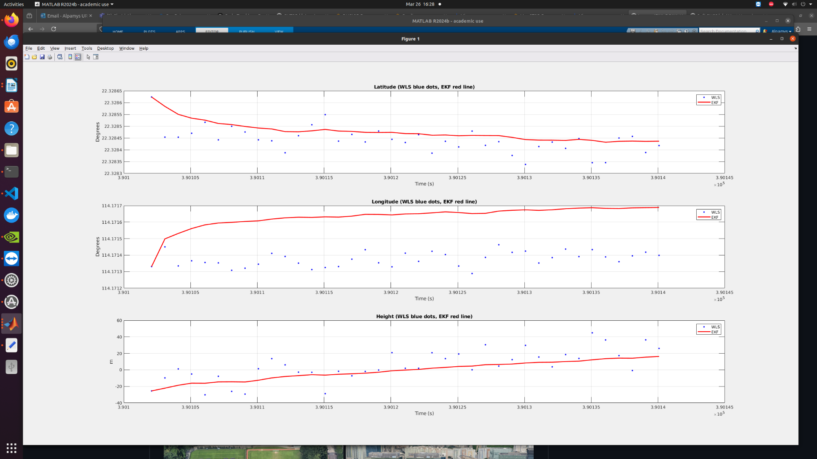

Fig. 14 Comparison of Latitude, Longitude and Height results derived by WLS (blue dots) method and EKF (red line) method (Opensky)

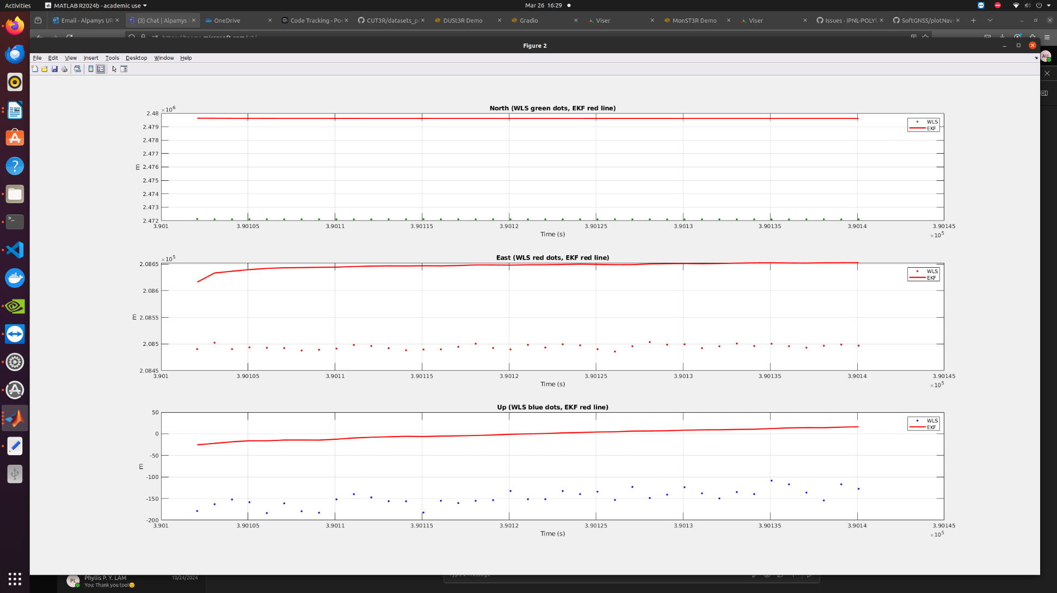

Fig. 15 Comparison of North, East, Up results derived by WLS (blue dots) method and EKF (red line) method (Opensky)

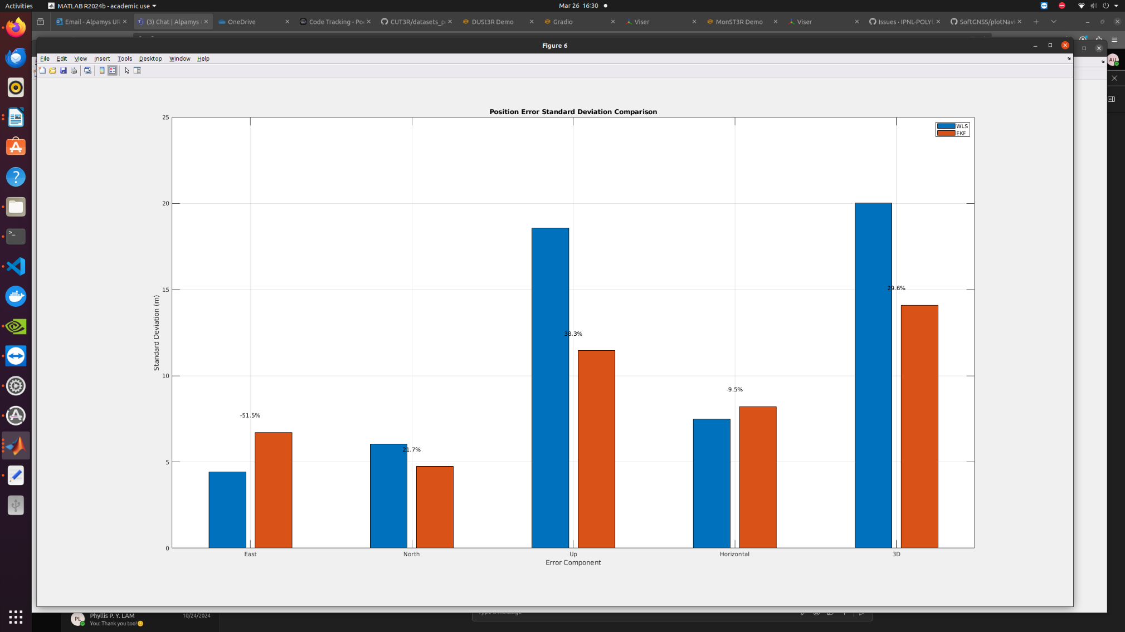

Fig. 16 Comparison of Position Error Standard Deviation from by WLS (blue dots) method and EKF (red line) method (Opensky)